**Making montage of stacks**

Note:

1. You need ImageJ 1.47. Older versions might not be compatible. 1.44 doesn’t work for sure.
2. If this macro doesn’t work on your computer, likely it’s because your computer handles file extension “.tif” differently than mine. Let me know and I’ll make small changes to the code for you.

Copy the folder “MovieMontage” to ImageJ’s plugin folder. There are several versions in it:

**MovieMontageMergeWColors**: merges 2 stacks into a stack of montages, with channels side by side and a merged one:

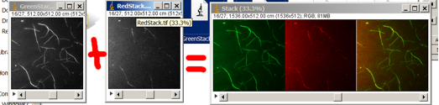

1. Name green and red stacks as “**GreenStack.tif**” and “**RedStack.tif**” respectively. Do all the **brightness/contrast** etc. adjustments at this step. Have both files open and close all other images.
2. Make a **temporary folder**, name doesn’t matter, for example, “temp”:

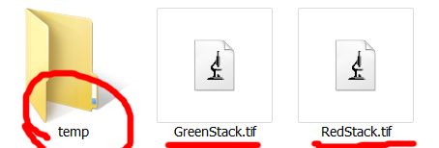

1. ImageJ->Plugins->Macros->**Run**…, select “MovieMontageMergeWColors” from the “MovieMontage” folder. When a window pops up, choose the **temporary folder** created in step 2, e.g. ”temp”.
2. Have a **coffee** and sing a **song**. It might take several songs if you have many frames or have a slow computer. After a while your final montage stack should pop up, named “**Stack**”. Make sure you save it. Example:
3. **Show off.**

**MovieMontageMerge**: Follow exactly the same steps as for “**MovieMontageMergeWColors**”. This macro keeps the two single-channel stacks grey in the final stack, like this:

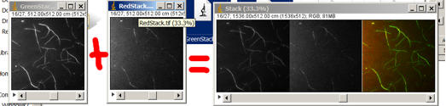

**MovieMontage**: Follow almost the same steps as for “**MovieMontageMergeWColors**”, but have the two initial stacks named “StackA.tif” and “StackB.tif”:

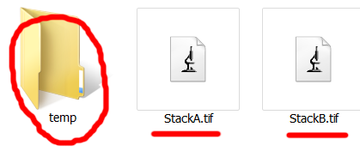

This macro doesn’t merge. It just combines two stacks side by side for comparison. It’s useful when you want to compare control vs non-control stacks on the same time-scale. StackA and StackB need to have the same number of frames.

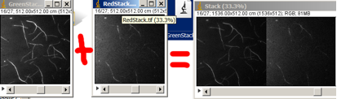

**MovieMontage3Movies, MovieMontage5Movies** Make montanges of 3 or 5 movies, respectively. Name your stacks StackA.tif/StackB.tif/StackC.tif or StackA.tif/StackB.tif/StackC.tif/StackD.tif/StackE.tif

Macros with “**RGB**” in their names will keep all color information and output RGB files.

The folder “**For_Slow_Computers**” has the same macros optimized for slow computers or large files. They work almost the same way as other macros, except:

1. Close all images before you start

2. When prompt, choose the folder that contains the source images and then a temporary folder

Export movies once you have all the stacks.